LẬP TRÌNH NÂNG CAO


Lecture 01: Generics, Collections

1. Giới thiệu về lập trình tổng quát Generics
programming
Mục lục | 2. Generic classes and methods  3. Giới thiệu Java Collections Framework
4. List, ArrayList, LinkedList
5. Giao diện Comparable, Comparator Interface
6. Queue, PriorityQueue, Deque
7. Set, HashSet, TreeSet
8. Luyện tập
9. Map, HashMap, TreeMap
10. Collections and Generics Best Practices

11. Luyện tập

Generic programming (Generic Types)
• | •
  Tổng quát hóa chương trình để có thể hoạt động với các kiểu dữ liệu khác nhau,
kể cả các kiểu dữ liệu trong tương lai (thuật toán đã xác định). Ví dụ, kiểu ngăn
xếp làm việc với các kiểu phần tử khác nhau.
• | Các kỹ thuật lập trình:
• | • | C, C++, Java từ 1.4 về trước: dùng con trỏ void, template, Object
• | • | Java 1.5,1.6: Generics
• | • | DotNet (C#): Generics


Generic programming (Generic Types)
• | •
  Sử dụng lớp tập hợp và các phép toán trên tập hợp để minh hoạ:
• | • | aSet.Member(element)
• | • | aSet.Insert(element)
• | • | aSet.Delete(element)
• | • | aSet.Count
• | • | aSet.Subset (anotherSet)
• | • | aSet.GetEnumerator()
• | • | aSet.Intersection (anotherSet)
• | • | aSet.Union (anotherSet)
• | • | aSet.Diff (anotherSet)

The classes IntSet
public class IntSet {
private int capacity; private static int DefaultCapacity = 10;
private int [] store; private int next;
public IntSet(int capacity)
{
this.capacity = capacity; store = new int [capacity]; next = 0;
}
public IntSet() {this(DefaultCapacity); }
public IntSet( int[] elements)
{ this(elements.length);
for (int i=0;i<elements.length;i++) this.Insert(elements[i]);
} // Copy constructor
public IntSet(IntSet s)
} | }
  { this(s.capacity);
  for (int i=0;i<s.next;i++) this.Insert(s.store[i]);
  }
  public bool Member( int element){ }
  public void Insert( int element){ store[next] =element; next++;}
  public void Delete( int element){ }
  5

and StringSet
public class StringSet{
private int capacity; private static int DefaultCapacity = 10;
private String [] store; private int next;
public IntSet(int capacity) {
} | }
  this.capacity = capacity; store = new String [capacity]; next = 0;
  }
  public IntSet() {this(DefaultCapacity); }
  public IntSet(String[] elements) {
  this(elements.length);
  for (int i=0;i<elements.length;i++) this.Insert(elements[i]);
  } // Copy constructor
  public IntSet(IntSet s) {
  this(s.capacity);
  for (int i=0;i<s.next;i++) this.Insert(s.store[i]);
  }
  // public bool Member(String element){ }
  public void Insert(String element){ store[next] =element; next++;}// public void Delete(String element){ }
  6

The class ObjectSet
public class ObjectSet{
private int capacity; private static int DefaultCapacity = 10;
private Object [] store; private int next;
public IntSet(int capacity) {
this.capacity = capacity; store = new Object [capacity]; next = 0;
}
public IntSet() {this(DefaultCapacity); }
public IntSet(Object[] elements)
{ this(elements.length);
for (int i=0;i<elements.length;i++) this.Insert(elements[i]);
} // Copy constructor
public IntSet(IntSet s)
} | }
  { this(s.capacity);
  for (int i=0;i<s.next;i++) this.Insert(s.store[i]);
  }
  // public bool Member(Object element){ }
  public void Insert(Object element){ store[next] =element; next++;}// public void Delete(Object element){ }
  7

Problems
•  • | •
  Problems with IntSet and StringSet
•  • | • | Tedious to write both versions: Copy and paste programming.
•  • | • | Error prone to maintain both versions.
•  • | Problems with ObjectSet
•  • | • | •
  Elements of the set must be downcasted in case we need to use some of their specialized operations.
8

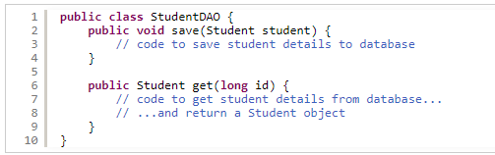
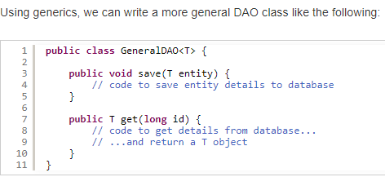
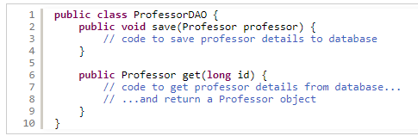
Generic Classes in Java

Generic Classes in Java
• | •
  Here, T is called type parameter of the GeneralDAO class. T stands for any
type. The GeneralDAO class is said to be generified. The following code
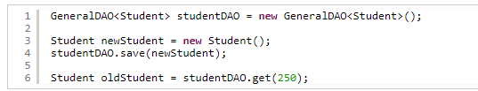
illustrates how to use this generic class:

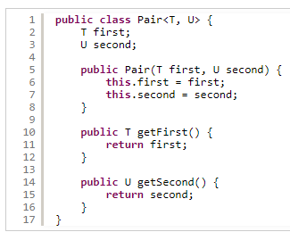
Generic classes with more than one
type parameter

Bounded type parameters
•  • | •  •
  Entity is called the upper bound, which can be any class or interface.
  The GeneralDAO class can be used only work with sub types of Entity, not with
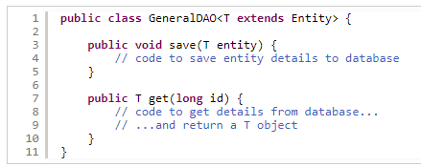
every type

Using multiple bounds
• | •
  We can use the syntax <T extends X & Y & Z> to define a generic class whose
type parameter can be sub types of multiple types. Here, X, Y, Z can be classes
and interfaces
• | •
  For example, the following generic class is designed works with only types that
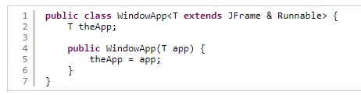
are sub types of Runnable and JFrame:

Generic Methods
• | •
  The following method counts number of occurrences of a String in an array of
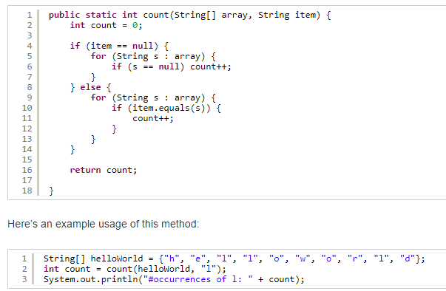
Strings:

Generic Methods
• | •
  Now, we need to count the occurrence of an element in an array of any type.
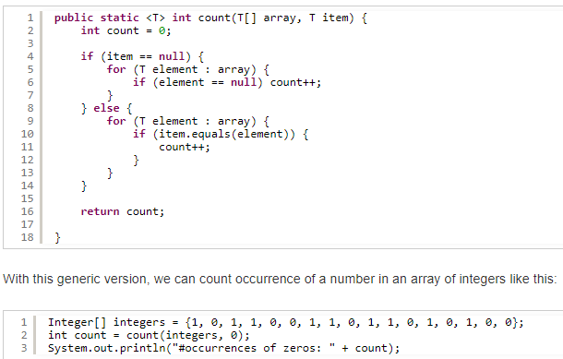
The <T> is always placed before the return type of the method

Generic Methods
• | Note that if the type parameter of a non-static generic method is same as the
enclosing class, the indicator <T> is not required. The following class illustrates this
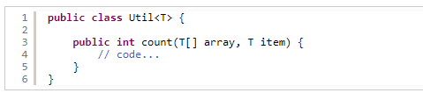
point:

Wildcards in generic methods
• | • | extends wildcard
• | • | •
  The compile only allows us to pass a collection of a subtype of Number
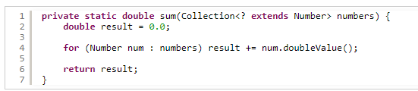
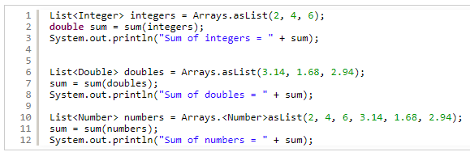

Wildcards in generic methods
• | •
  super wildcard (áp dụng với lớp tương ứng và các lớp cha)
• | • | Do lớp Numer là lớp cha của tất các các lớp: BigDecimal, BigInteger,
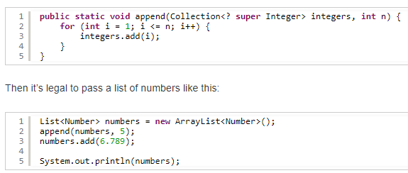
Byte, Double, Float, Integer, Long, Short

Java Collections Framework
• | A collection is a data structure that holds a set of objects. It looks like arrays but
collections are more advanced and more flexible.
•  • | •  •
  Java Collections Framework is a set of reusable data structures and algorithms.
  Why Use Java Collections Framework
•  • | • | Reduce programming effort: with the reusable and useful data structuresand algorithms, the programmers do not have to re-invent the wheel, thus they  can devote their time on developing application’s business.
•  • | • | Increase program speed and quality
•  • | • | Software reuse: due to the Java Collections Framework is built into the JDK,  code written using collections framework can be re-used every where amongapplications, libraries and APIs. That cuts development cost and increasesinteroperability among Java programs.

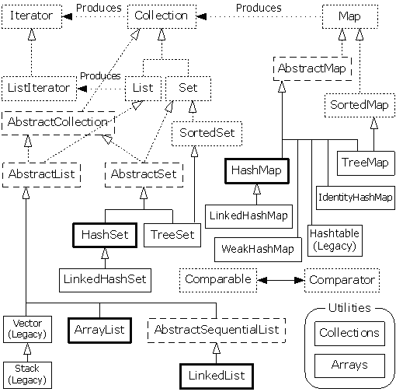
Java Collections Framework

Java Collections Framework
• | Starting with Java 5, a collection holds objects of a specified type (tổng quát). A
collection class’s or interface’s definition takes object type as a parameter:
• | • | Collection<E>
• | • | List<E>
• | • | Stack<E>
• | • | Set<E>
• | •
  A map takes two object type parameters:
• | • | Map<K,V>

Collection, Iterator Interface
  «interface»
  Iterator
  «interface»
  Collection
• Collection interface represents any collection.
• An iterator is an object that helps to traverse the collection
(process all its elements in sequence).
• A collectionsuppliesits collection’s iterator method); | own | iterator(s), | (returned | by
22

Collection<E> Methods
 |  | Supplies an iterator for this collection
  «interface»
  Iterator
  «interface»
  Collection
 |  | Supplies an iterator for this collection
  boolean isEmpty ()
  int size ()
  boolean contains (E obj)
  boolean add (E obj)
  boolean remove (E obj)
  Iterator<E> iterator ()
  // ... other methods
23

Iterator<E> Methods
  «interface»
  Iterator
  «interface»
  Collection
  ...
 | What’s “next” is
  boolean hasNext ()
  E next ()
  void remove ()
determined by a
particular collection
Removes the last visited element | Collection c;
Removes the last visited element | Iterator it = c.iterator();
24

Iterator ⇔ “For Each” Loop
Collection<String> words = new ArrayList<String>(); ...
  for (String word : words) {
  < ... process word >
  }
  Iterator<String> iter =
  words.iterator();
  while (iter.hasNext ()) {
  String word = iter.next ();
  < ... process word >
  }
A “for each” loop is a
syntactic shortcut that
replaces an iterator
25

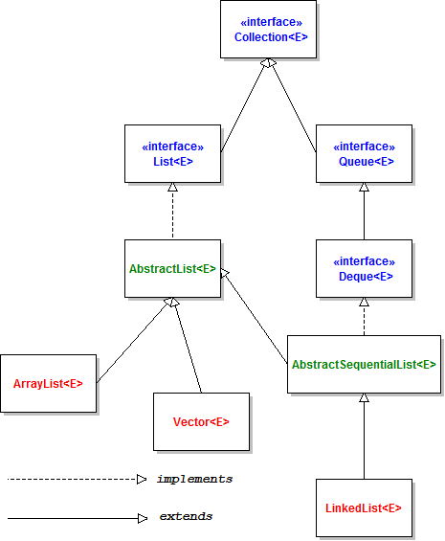
List Collection

Lists, ListIterator
•  •  • | •  a0, a1, ..., an-1  java.util:
  A list represents a collection in which all elements are numbered by indices:
•  •  • | • | List, ListIterator interface
•  •  • | • | ArrayList
•  •  • | • | LinkedList
•  •  • | •
  ListIterator is an extended iterator, specific for lists (ListIterator is a subinterface
of Iterator)
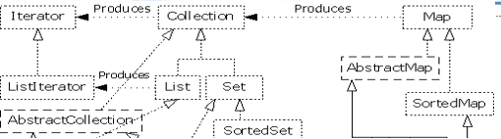
27

List<E> Methods
 | These methodsarefrom ArrayList,  implements List | familiar  which
  // All Collection<E> methods, plus:E get (int i)
  E set (int i, E obj)
  void add (int i, E obj)
  E remove (int i)
  int indexOf (Object obj)
  ListIterator<E> listIterator ()
  ListIterator<E> listIterator (int i)
 | Returns  iterations at index i  aListIterator | that | starts
28

ListIterator<E> Methods
// The three Iterator<E> methods, plus:int nextIndex ()
boolean hasPrevious ()
E previous ()
int previousIndex ()
void add (E obj)
void set (E obj)

Can traverse the list backward
Can add elements to the list (insertsafter the last visited element)
Can change elements (changes
the last visited element)

ArrayList
•  •  •  • | •  Static array?  •
  Represents a list as a dynamic array (array that is resized when full)
  Provides random access to the elements
•  •  •  • | Implements all the methods of List<E> a0a1a2...an-1

LinkedList
•  • | •  •
  Represents a list as a doubly-linked list with a header node
  Implements all the methods of List<E>

header

 |  |  | ...
  a0
  a1
  a2
  an-1
31

LinkedList (cont’d)
• | •
  Additional methods specific to LinkedList:

void addFirst (E obj)
void addLast (E obj)
E getFirst ()
E getLast ()
E removeFirst ()
E removeLast ()
32

• | ArrayList | vs. LinkedList | • | Implements a list as a doubly-linked list witha header node
• | Implements a list as an array |  | • | Implements a list as a doubly-linked list witha header node
+ | Provides random access to the elements |  | - No random access to the elements — needs
- | Inserting and removing elements requires |  | to traverse the list to get to the i-th element
- |  |  | + Inserting and removing elements is done by rearranging the links — no shifting
- | shifting of subsequent elements
- | Needs to be resized when runs out of space |  | + Nodes are allocated and released as  necessary
33

ArrayList vs. LinkedList (cont’d)
 | ArrayList | LinkedList
get(i) and set(i, obj) | O(1) | O(n)
add(i, obj) and remove(i) | O(n) | O(n)
add(0, obj) | O(n) | O(1)
add(obj) | O(1) | O(1)
contains(obj) | O(n) | O(n)
34

ArrayList vs. LinkedList (cont’d)
Iterator iter = list.iterator ( );while (iter.hasNext ( )) {
Object x = iter.next ( );
...
}

for (int i = 0; i < list.size(); i++) { Object x = list.get (i);
...
}

Works well for an ArrayList ⎯ O(n)  inefficient for a
  for (Object x : list) {
  ...
  }
LinkedList ⎯ O(n2) | Work well for bothan ArrayList and a LinkedList ⎯ O(n) | 35

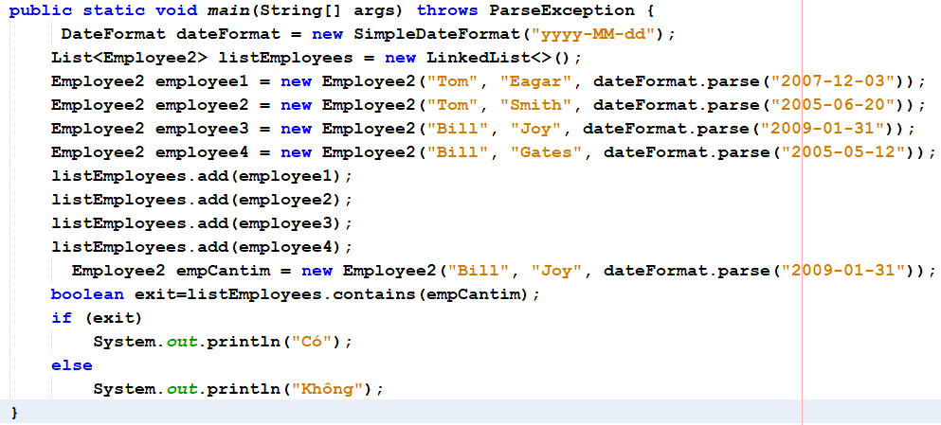
Contains method

Utility classes: Collections and Arrays
• | Collections.sort(list):
- sort (List<T> list)
- binarySearch (List<? extends T> list,T key, Comparator<? super T> c)
• | Arrays:
- sort (T[] a, Comparator<? super T> c)
- binarySearch (T[] a, T key, Comparator<? super T> c)

Utility classes: Collections and Arrays
• | .
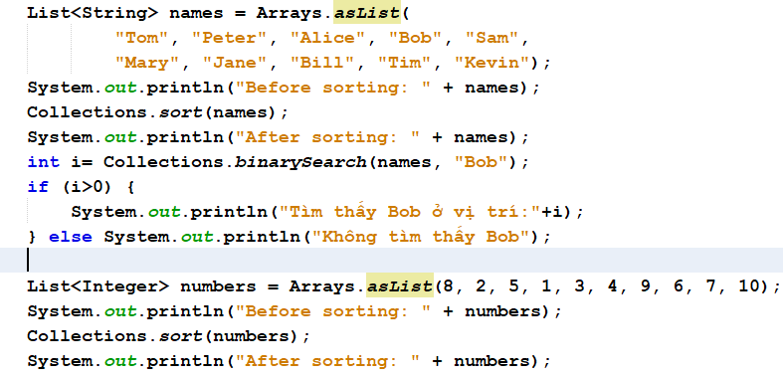

Utility classes: Collections and Arrays
• | .
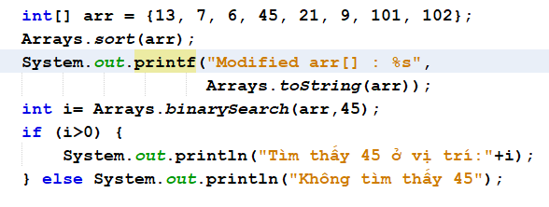

Object Ordering in Java
• | Lỗi biên dịch:
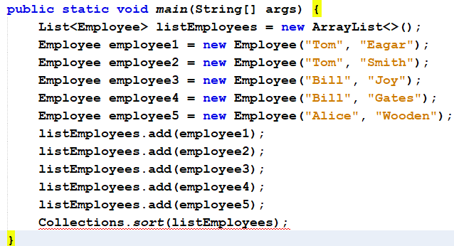
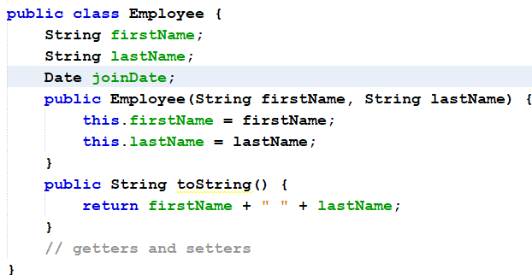

Object Ordering in Java
• | Giao diện Comparable
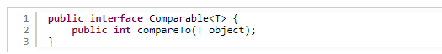
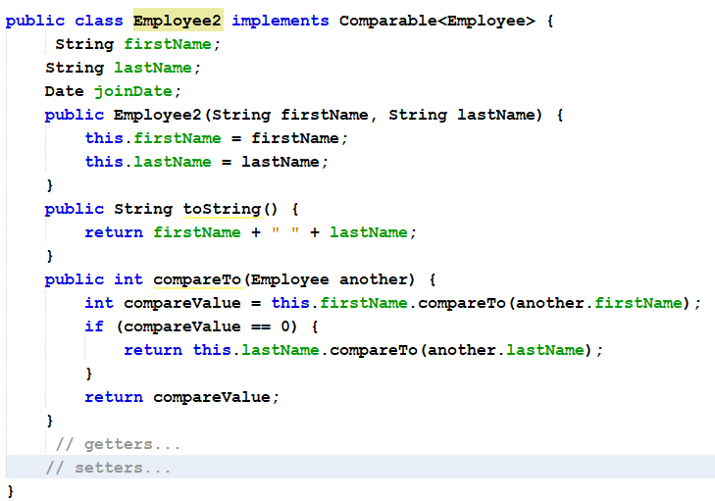

Object Ordering in Java
•  • | Giao diện Comparator  Demo
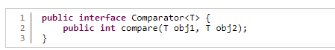
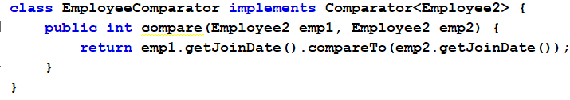

Stacks
•  •  •  • | •  •
  A stack provides temporary storage in the LIFO (Last-In-First-Out) manner.
  Stacks are useful for dealing with nested structures and branching processes:
•  •  •  • | • | pictures within pictures
•  •  •  • | • | folders within folders
•  •  •  • | • | methods calling other methods
•  •  •  • | •  •
  Controlled by two operations: push and pop.
  Implemented as java.util.Stack<E> class

Stack<E> Methods
 | Returns obj; use as void  Returns thetopelement  without removing it from the  stack
  boolean isEmpty ()
  E push (E obj)
  E pop ()
  E peek ()

Queue Interface
• | •
  A queue provides temporary storage
in the FIFO (First-In-First-Out) manner
• | •
  Useful for dealing with events that
have to be processed in order of their
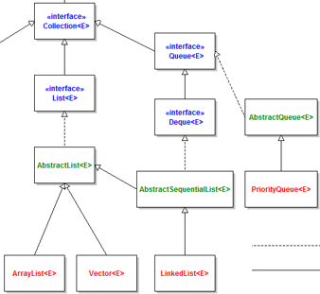
arrival

Queue<E> Methods
boolean isEmpty ()
boolean add (E obj)
E remove ()
E peek ()

Returns the first element withoutremoving it from the queue

Priority Queues
• | •
  In a priority queue, items are processed
NOT in order of arrival, but in order of
priority.
• | java.util:
• | • | Queue interface
• | • | PriorityQueue (implements Queue)

PriorityQueue<E> Class
•  •  •  •  •  - | •  •  •  •  Thực hành:  -
  Works with Comparable objects (or takes a comparator as a parameter).
  The smallest item has the highest priority.
  Implements a priority queue as a min-heap (Cấu trúc đống min – Heap Sort)
  Both add and remove methods run in O(log n) time; peek runs in O(1) time.
  Tạo ra một hàng đợi gồm các sinh viên ưu tiên (ai điểm cao nhất được ưu tiên
trước).
- | -
  Tạo ra một hàng đợi gồm các nhân viên (hoten, ngaysinh,..) ưu tiên (tuổi cao
nhất thì được ưu tiên trước).

Sets
•  • | •  •
  A set is a collection without duplicate values
  What is a “duplicate” depends on the
implementation
• | java.util:
• | • | Set interface
• | • | SortedSet interface
• | • | TreeSet
• | • | HashSet
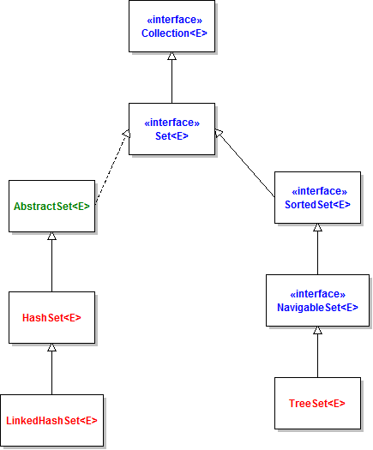
•

Set<E> Methods
Methods of Set<E> are the same as methods of Collection<E>
Set’s semantics are different fromCollection (no duplicates), but Setdoes not add any new methods.
50

SortedSet
• | •
  SortedSet kế thừa từ Set, nó hỗ trợ thao tác trên tập hợp các phần tử có
thể so sánh được.
• | •
  Các đối tượng đưa vào trong một SortedSet phải cài đặt giao tiếp
Comparable hoặc lớp cài đặt SortedSet phải nhận một Comparator trên
kiểu của đối tượng đó.
• | Một số phương thức của SortedSet<E>:
• | • | E first(); // lấy phần tử đầu tiên (nhỏ nhất)
• | • | E last(); // lấy phần tử cuối cùng (lớn nhất)
• | • | SortedSet subSet(E e1, E e2); // lấy một tập các phần tử nằm trong khoảng từ e1 tới e2.

TreeSet<E>
•  •  •  • | •  •  •  •
  Works with Comparable objects (or takes a comparator as a parameter)
  Implements a set as a Binary Search Tree (Red Black Tree)
  contains, add, and remove methods run in O(log n) time
  Iterator returns elements in ascending order
52

HashSet<E>
• | •
  Works with objects for which reasonable hashCode and equals methods are
defined; hashCode method = hash function; equals method is used for finding
object.
•  •  • | •  •  •
  Implements a set as a hash table
  contains, add, and remove methods run in O(1) time
  Iterator returns elements in no particular order
53

equals() & hashCode() with HashSet
• | •
  How does a Set prevents duplicate entries:
The Solution is, we have to override hashCode() and equals() method in our
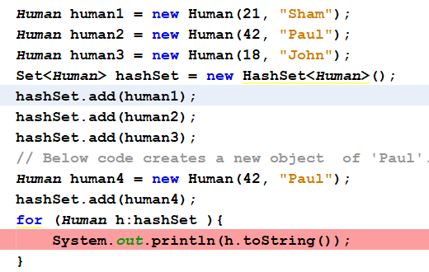
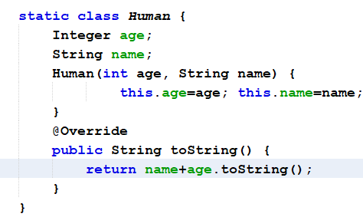
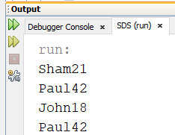
class.

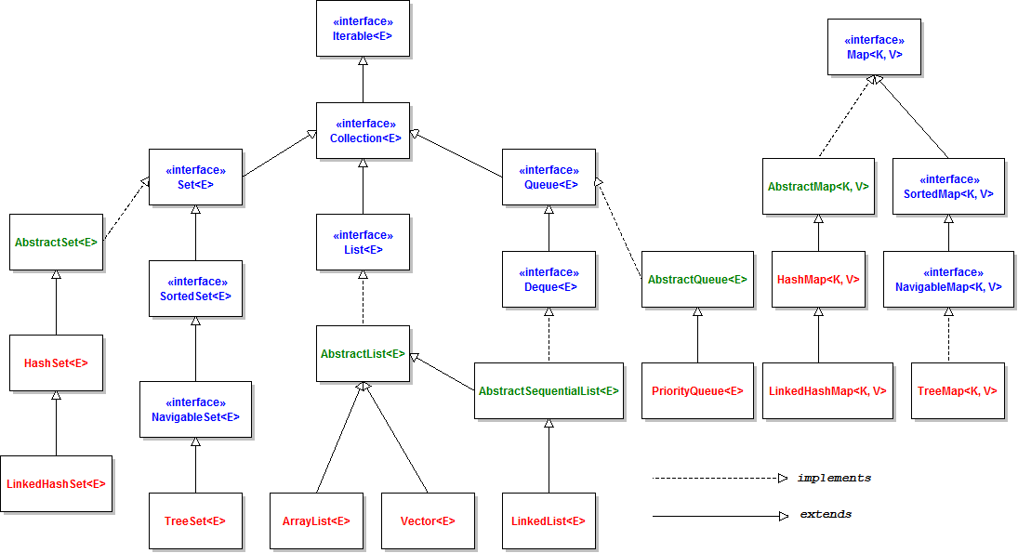
Map Collection

Map Collection
• | •
  A map is not a collection; it represents a correspondence between a set of keys
and a set of values
• | •
  Only one value can correspond to a given key; several keys can be mapped onto
the same value
 | keys | values
56

Maps (cont’d)
• | java.util:
• | • | Map interface
• | • | SortedMap interface
• | • | TreeMap
• | • | HashMap
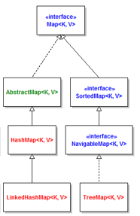
57

Map<K, V> Methods
 | Returns the set  of all keys
  boolean isEmpty ()
  int size ()
  V get (K key)
  V put (K key, V value)
  V remove (K key)
  boolean containsKey (Object key)
  Set<K> keySet ()
58

TreeMap<K,V>
•  •  • | •  •  •
  Works with Comparable keys (or takes a comparator as a parameter)
  Implements the key set as a Binary Search Tree (Red Black Tree)
  containsKey, get (tìm kiếm theo kiểu khoá-giá trị), and put methods run in O(log
n) time
59

HashMap<K,V>
• | •
  Works with keys for which reasonable hashCode and equals methods are
defined
•  • | •  •
  Implements the key set as a hash table
  containsKey, get (key-value), and put methods run in O(1) time
60

Methods: hashCode and equals
• | •
  HashMap and HashSet use the hashcode value of an object to find out how the
object would be stored in the collection, and subsequently hashcode is used to
help locate the object in the collection.
• | •
  HashMap and HashSet work as follows:
• | • | First, find out the right bucket using hashCode().
• | • | Secondly, search the bucket for the right element using equals()

Methods: hashCode and equals
•  • | •  Output:
  Case 1: Overriding both equals(Object) and hashCode() method
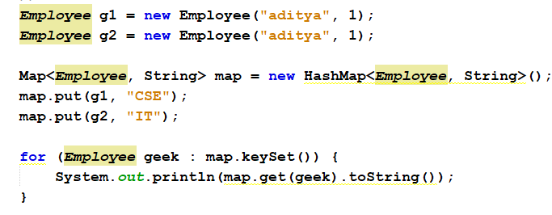
IT

Methods: hashCode and equals
•  • | •  Output:
  Case 2 : Overriding only the equals(Object) method
CSE
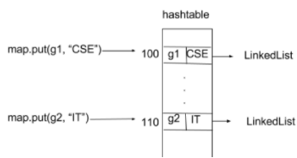
IT

Methods: hashCode and equals
•  • | •  Output:
  Case 3: Overriding only hashCode() method
CSE
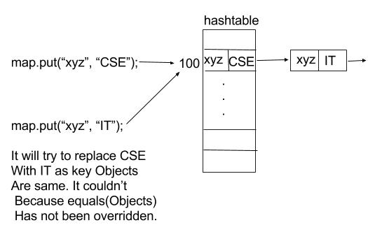
IT

Case Study: Stock Exchange
(giao dịch chứng khoán)
•  •  • | •  •  •
  Implements a toy stock exchange (giao dịch chứng khoán nhỏ)
  Can be structured as a team development project
  Uses TreeSet, TreeMap, HashMap, Queue, and PriorityQueue classes
19-65

SafeTrade Structural Design
Data | interface => class
Registered traders | Map => TreeMap<String, Trader>
Logged-in traders | Set => TreeSet<Trader>
Mailbox for each trader | Queue => LinkedList<String>
Listed stocks | Map => HashMap<String, Stock>
Sell orders for each stock | Queue => PriorityQueue<TradeOrder>  (with ascending price comparator)
Buy orders for each stock | Queue => PriorityQueue<TradeOrder>  (with descending price comparator)
19-66

Case Study: Stock Exchange
(giao dịch chứng khoán)
•  •  • | •  •  •
  Implements a toy stock exchange (giao dịch chứng khoán nhỏ)
  Can be structured as a team development project
  Uses TreeSet, TreeMap, HashMap, Queue, and PriorityQueue classes
19-67

Collections and Generics Best Practices
1. Choosing the right collections
• | To know which kind of collection (List, Set, Map, Queue, etc) is appropriate to solve
the problem, you should figure out the characteristics and behaviors of each and
the differences among them.
• | Basically, you decide to choose a collection by answering the following questions:- Does it allow duplicate elements?  - Does it allow accessing elements by index?  - Does it offer fast adding and fast removing elements?

Collections and Generics Best Practices
2. Always using interface type when declaring a collection
• | •
  What’s the difference between (1) and (2)?
In (1), the type of the variable listNames is List, and in (2) listNames has type
of ArrayList. By declaring a collection using an interface type, the code would be more
flexible as you can change the concrete implementation easily when needed, for
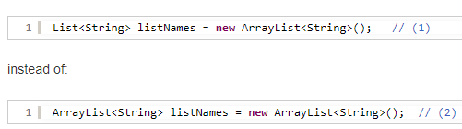
example: Có thể đổi từ ArrayList sang LinkedList khi cần.

Collections and Generics Best Practices
2. Always using interface type when declaring a collection
The flexibility of using interface type for a collection is more visible in case of
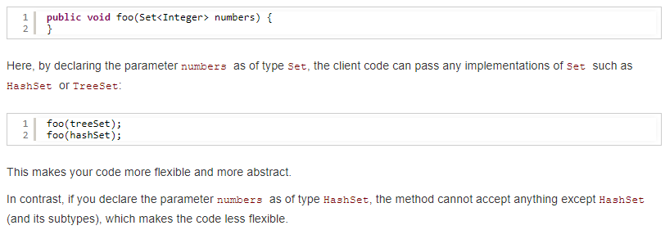
method’s parameters. Consider the following method:

Collections and Generics Best Practices
2. Always using interface type when declaring a collection
It’s also recommended to use interface as return type of a method that returns a
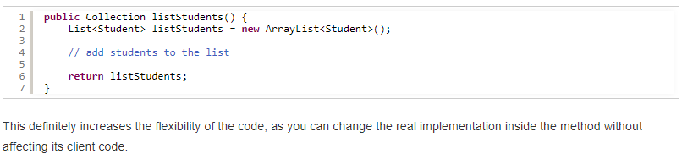
collection, for example:

Collections and Generics Best Practices
3. Use generic type and diamond operator
The <> is informally called the diamond operator (Java 1.7). This operator is quite
useful. Imagine if you have to declare a collection like this:
Without the diamond operator, you have to repeat the same declaration twice:
Map< Integer, Map<String, Student> > map
= new HashMap< Integer, Map<String, Student> >();
So the diamond operator saves you:
Map<Integer, Map<String, Student>> map = new HashMap<>();

Collections and Generics Best Practices
4. Specify initial capacity of a collection if possible
Ex: List<String> listNames = new ArrayList <String>(5000);
5. Prefer isEmpty() over size()
Avoid checking the emptiness of a collection like this:
if (listStudents.size() > 0) {
// dos something if the list is not empty
}
Instead, you should use the isEmpty() method:
if (!listStudents.isEmpty()) {
// dos something if the list is not empty
}

Collections and Generics Best Practices
6. Do not return null in a method that returns a collection
A null value should not be used to indicate no result. The best practice is, returning an
empty collection to indicate no result.
Ex:
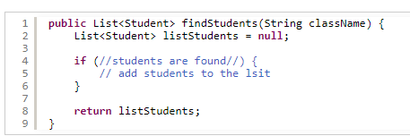
Dòng 2 cần thay bằng List<Student> listStudents = new ArrayList<>;

Collections and Generics Best Practices
7. Do not use the classic for loop
Không nên sử dụng dạng classic:
Có thể sử dụng dạng:
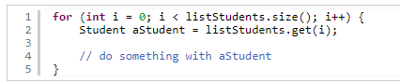
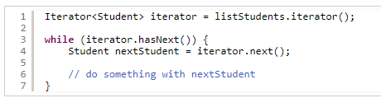
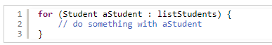
Tốt nhất là dạng:



